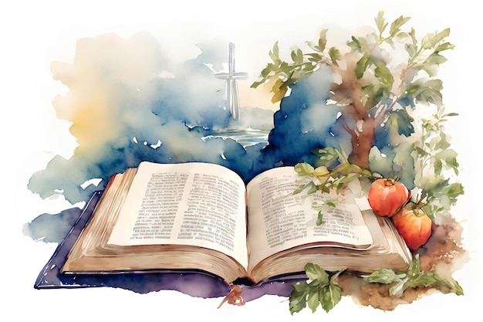
2026
WELCA WOMEN’S RETREAT
INFORMATION SHEET
Mon. June 29 & Tue. June 30

Presenter: Pati Kachel
God Is Writing Your Story
Music: Sue Saarem
Hosted by: Women of the ELCA
Northwest Synod of Wisconsin
Jacki Johnson – coordinator 715-864-1489

Held at: Luther Park Bible Camp
944 24 ¼ Street Chetek, WI

Full 2 day - Retreat - Early Bird Registration $95 postmarked by 6/5/26. $120 postmarked after 6/5/26
This includes 4 meals, overnight lodging in a handicap accessible cabin, cabins sleep 6 women
(per side – 2 sides), Speaker, camp activities, and costs to host the retreat.
Needed items for overnight stay: Bible and pen along with personal items, towels, pillows, bedding or sleeping bag, flashlight, swimsuit (if you want to swim), snacks, camera, and spending money.

Monday only, Early Bird Registration $65 postmarked by 6/5/26. $90.00 postmarked after 6/5/26
This includes 2 meals, Speaker, camp activities, and costs to host the retreat.
Needed items for one day retreat: Bible and pen along with swimsuit (if you want to swim), towel, camera, and spending money.

*NO ONSITE Registration* and *No early check-ins for Cabins*
*No refunds, but registration can transfer to another woman*

Registration: Monday – 9:00 A.M. – 10:15 A.M. in the Ministry Center
First time participant orientation begins at 9:15 a.m. and 9:40 a.m.

A free will offering will be taken with proceeds going to
(Church Women’s Group and Personal offerings are encouraged)
½ WELCA for Synod use
¼ Luther Park
¼ Feed My People

TO BE ECO FRIENDLY – PLEASE BRING YOUR OWN RE-FILLABLE WATER BOTTLE
WATER JUGS WILL BE PROVIDED BY THE CAMP - PLASTIC BOTTLES OF WATER WILL NOT BE PROVIDED
REGISTRATION FORM
Early bird rates apply if postmarked by 6/5/2026
2026
WELCA WOMEN’S RETREAT

Mon. June 29 & Tue. June 30

Meet our Presenter: Pati Kachel
Pati loves God, His people, and His Holy Word….and she loves to tell stories about all of these!
Pati’s stories are humorous, heartwarming and above all, Christ-centered.
Drawing on her Norwegian and German heritage, Pati weaves family stories and colorful characters into her homespun tales.
Check out The Parable Fund to learn more about Pati.
https://www.theparablefund.org/bio

--------------PLEASE DUPLICATE THIS FORM AS NEEDED-------------
Registration required by June 22nd
Make Checks Payable to WELCA (not your church or Luther Park)
Send to: Barb Krug @ 883 Brucker Street Medford, WI 54451
Questions: call or text 715-965-5696 email: barbkrug@charter.net

Name: First & Last (as you would like it on your name tag) ________________________________________
Is this your 1st retreat? _______ Would you like an orientation at the camp?____________________
Address: ___________________________________________________________________________
Email______________________________________________________________________________
Telephone: _________________________________________________________________________
Church Name and City________________________________________________________________
Attending only on Monday ____________________________________________________________
Do you have any special dietary requirements? ___________________________________________

